Day-19:

Task

Top command : check process is running or not

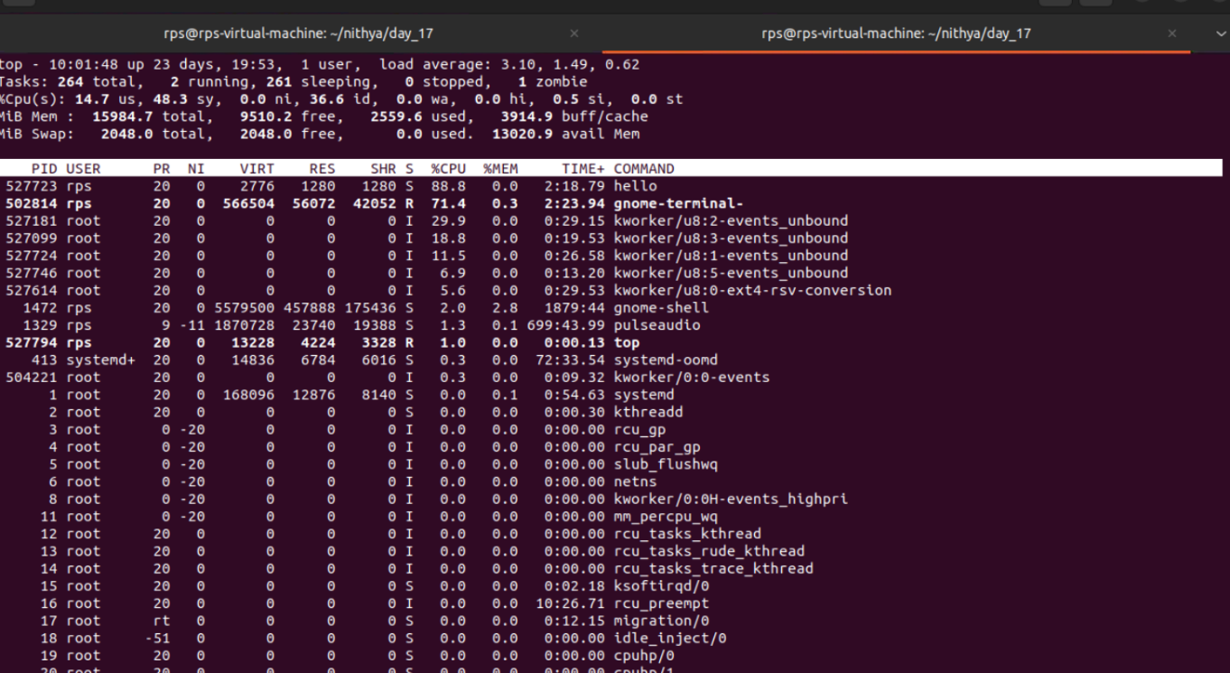

After process stop

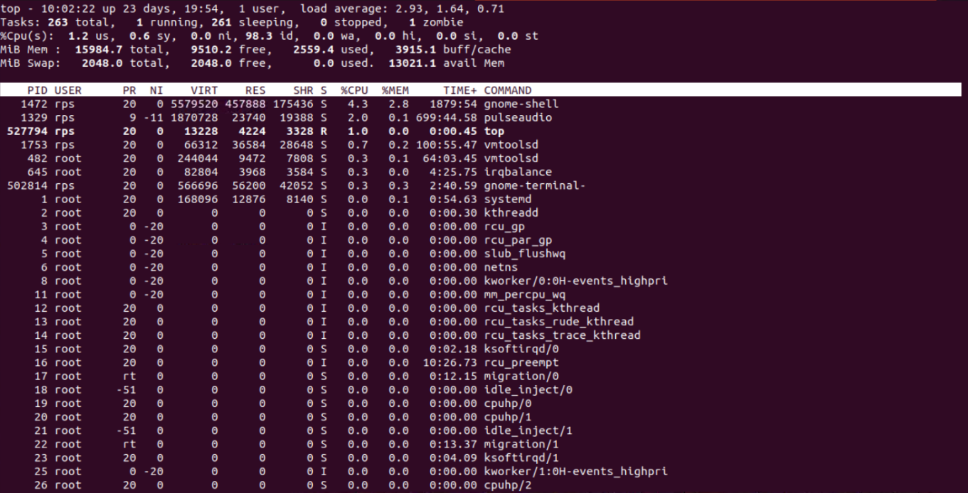

Kill command to stop the process

Before kill the process

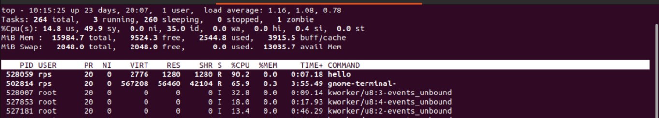

Killing process

Capture2.PNG

After kill the process

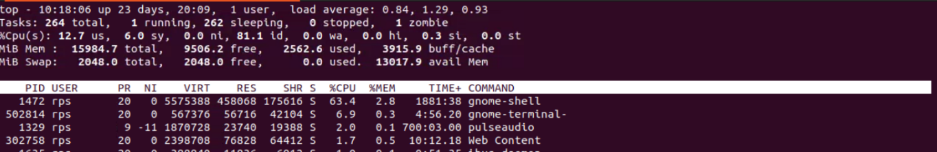

**Program for hello world:**

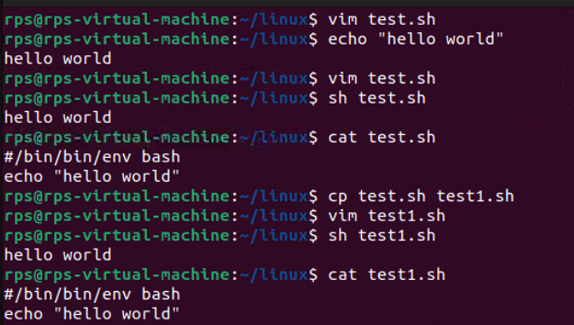

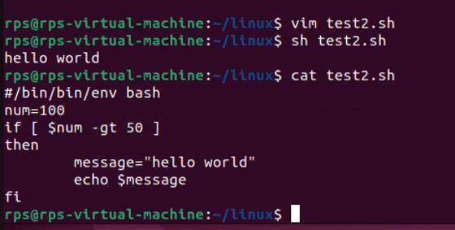

**Using if-else:**

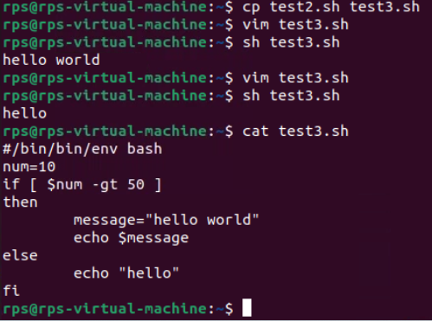

**Using for-loop:**

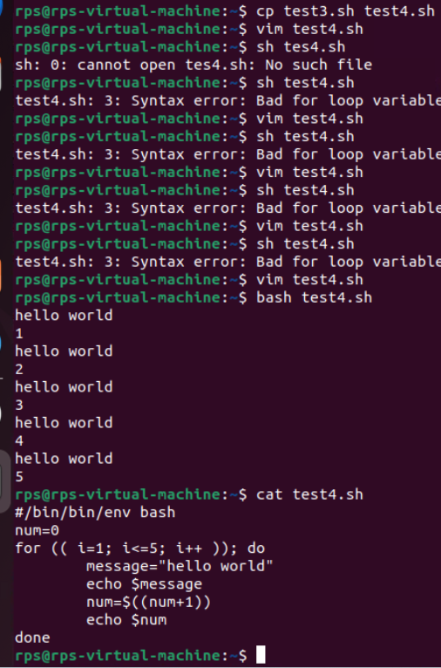

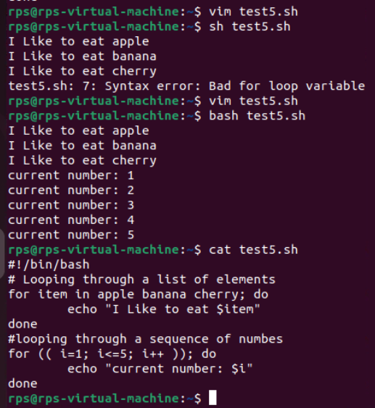

Bash Scripting: Exercise

Exercise 1: Write a shell script called num_loop.sh that loops through every number 1 through 20 and prints each number to standard output. The script should also conditionally print I'm big! for every number larger than 10.

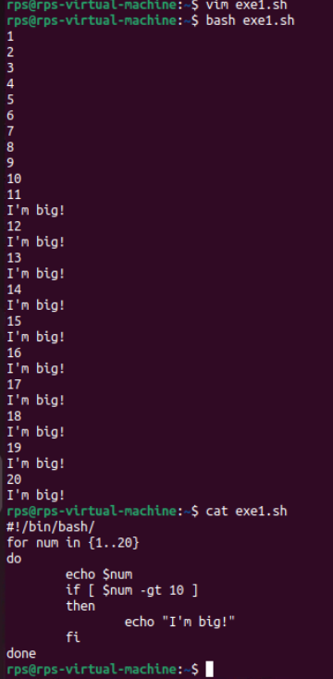

**Exercise 2: Write a shell script called my_folder. sh that takes in two arguments: your name (e.g. ayelet) and your name with the .txt ending (e.g. ayelet.txt). The script should call a function that creates a folder by the name of the first argument (e.g. ayelet) and then create a file inside by the name of the second argument(e.g.ayelet.txt).**

**For my name, my function would create a folder named ayelet and a file. named ayelet.txt inside of ayelet.**

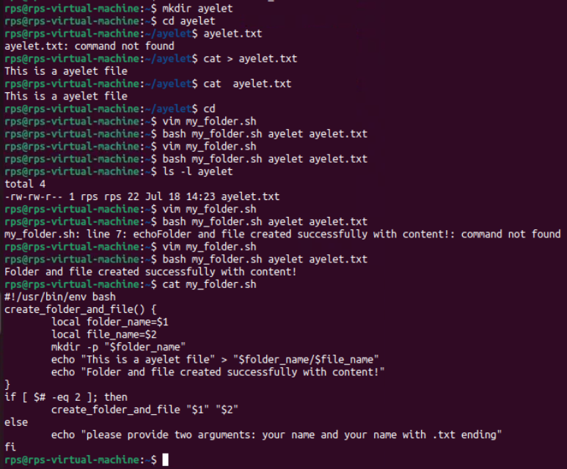

### Commands

**File Search**:  
Write a command to find all files with the extension .txt in the /home directory and its subdirectories.

find /home -type f -name "*.txt"

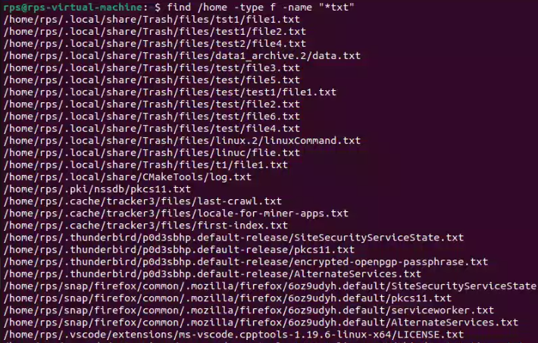

**File Permissions**:  
Write a command to change the permissions of all files in the /var/log directory to 644.

find /var/log -type f -execchmod 644 {} \;

Capture2.PNG

**Disk Usage**:  
Write a command to display the disk usage of all directories in the /home directory in a human-readable format.

du -h --max-depth=1 /home

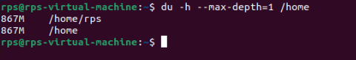

**Process Management**:  
Write a command to list all running processes that contain the name "apache" in their command line.

ps aux | grep apache

Capture4.PNG

**Text Processing**:  
Write a command to count the number of lines in a file named error.log.

wc -l error.log



**Network Configuration**:  
Write a command to display the IP address of all network interfaces on the system.

ipaddr show | grep "inet "

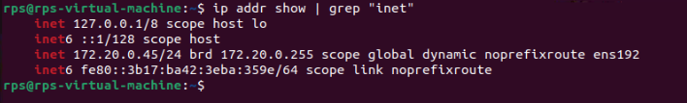

**Package Management**:  
Write a command to install a package named htop using the package manager.

sudo apt-get install htop

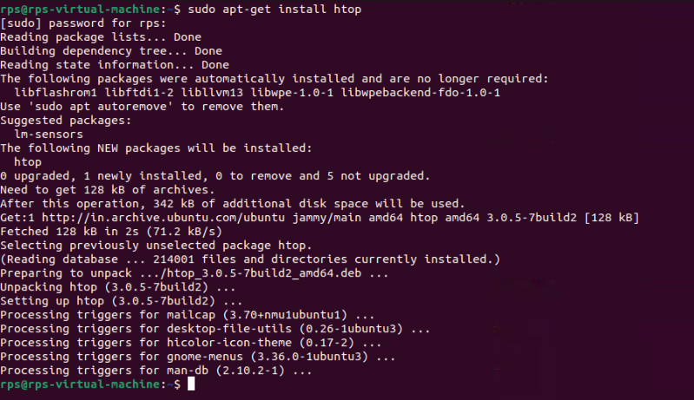

**User Management**:  
Write a command to add a new user named developer to the system.

Sudo useradd developer

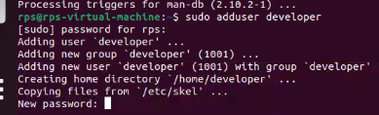

**File Compression**:  
Write a command to compress a directory named backup into a .tar.gz file.

tar -czvf backup.tar.gz backup

**System Monitoring**:  
Write a command to display real-time system resource usage, including CPU, memory, and disk I/O.

Top



**Shell Scripts**

**Backup Script:**

**Write a shell script to back up a directory named /data to /backup with the current date appended to the backup file name.**

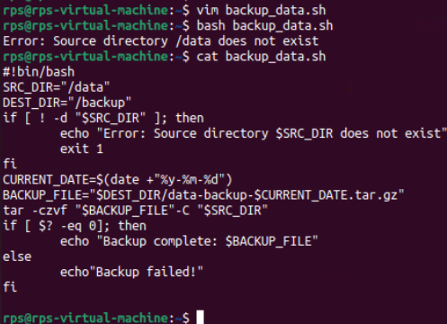

**Log Rotation:**

**Write a shell script to rotate log files in the /var/log directory, keeping only the last 7 days of logs.**

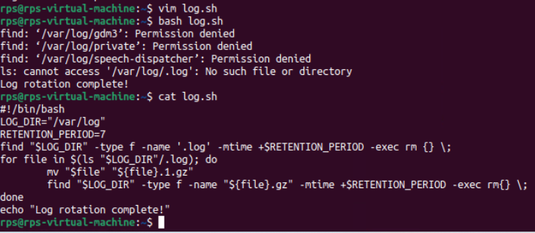

**User Report:**

**Write a shell script to generate a report of all users currently logged into the system and save it to a file named user_report.txt.**

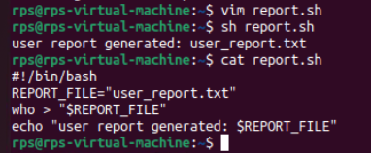

**Disk Space Alert:**

**Write a shell script to check the disk usage of the /home directory and send an email alert if the usage exceeds 80%.**

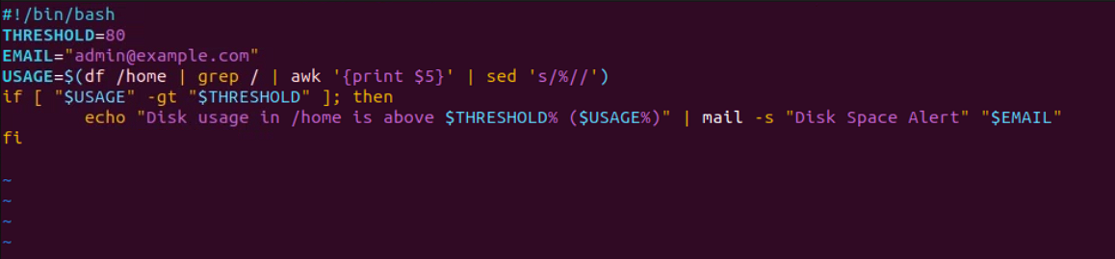

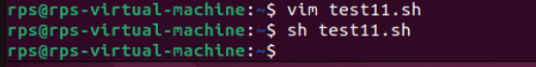

**Service Monitor:**

**Write a shell script to check if the nginx service is running and restart it if it is not.**

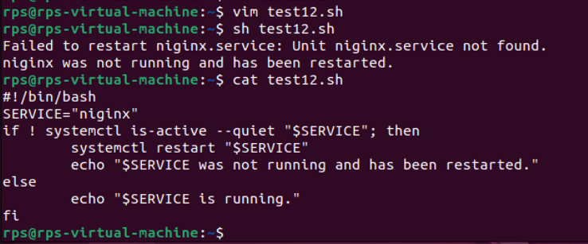

**File Cleanup:**

**Write a shell script to delete all files older than 30 days in the /tmp directory.**

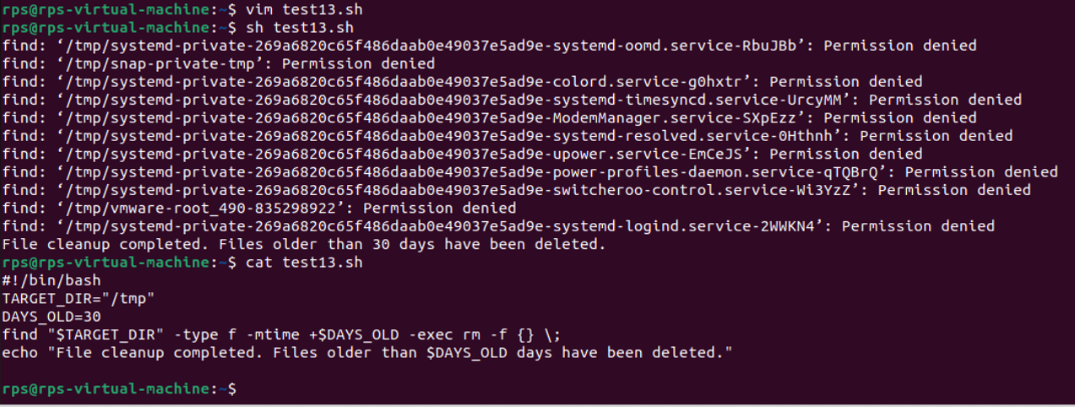

**Automated Updates:**

**Write a shell script to automatically update all installed packages on the system.**

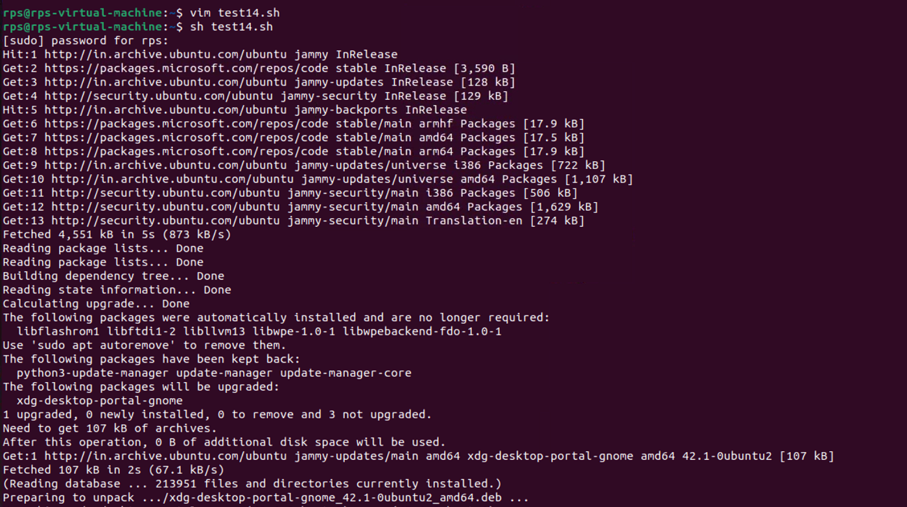

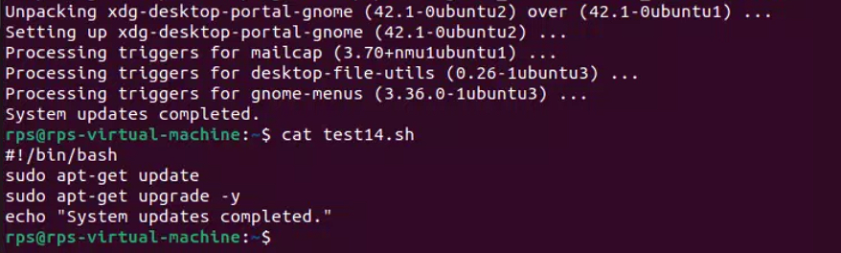

**Database Backup:**

**Write a shell script to back up a MySQL database named sales to a file named sales_backup.sql.**

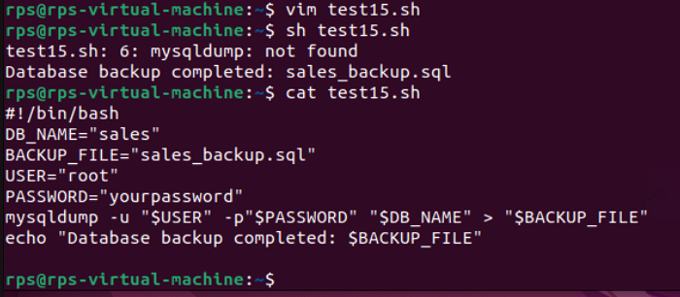**System Information:**

**Write a shell script to display system information, including hostname, OS version, and kernel version.**

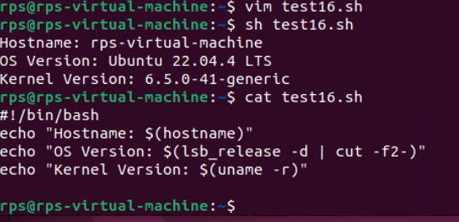

**Cron Job:**

**Write a shell script to schedule a cron job that runs a specific command every day at midnight.**

